

May is Mental Health Awareness Month
May is upon us which means it’s Mental Health Awareness Month. Some have never given the observance a second thought, while others are reminded of the struggles or mental health challenges they or a loved one has experienced. Regardless of your situation, it’s also a time to recognize the importance of our mental health and well-being, which cannot be overstated.
What, then, can be done to address these concerns and improve overall health? Surprisingly, many of the upstream prevention recommendations to help people manage their physical health are also identified as ways to support mental health and well-being. For several years, research studies have identified links between various physical ailments and mental ones. According to the Mayo Clinic, high blood pressure, strokes, heart disease, obesity and diabetes have shown to have roots in elevated stress or anxiety levels. Being active is one simple step you can take towards establishing a regular routine that supports both physical and mental-well being, because physical activity releases beneficial endorphins and can reduce stress causing cortisol in your system. You don’t need to be an avid runner or gym member to be physically active and see positive benefits. Taking the stairs instead of the elevator or walking your dog can begin your efforts toward establishing a physically active lifestyle. The Centers for Disease Control and Prevention (CDC) recommends that all able bodied-adults get at least 150 minutes (two and a half hours) of moderate-intensity activity per week, such as brisk walking, and at least 2 days a week of muscle strengthening activities. By following the CDC guidelines, the American Psychological Association studied outcomes and concluded that adults who were active saw a 25% reduction in depression. They also indicated that 11% of all cases of depression could be prevented just by following these guidelines. Keep in mind, physical activity can increase your heart rate, so check with your healthcare provider to learn about what diet and activities will work best for you.
Mental health professionals are also available either in-person or virtually to provide guidance and counseling services for individuals and families to support mental health and wellbeing needs. According to a Harvard study, nearly 1 in 4 adults felt they had no one in their lives who they could talk to and noted that loneliness was just the tip of the iceberg. Data also suggested that underneath, there were other troubling feelings, including anxiety, depression and a lack of meaning and purpose.
In addition to being more active and seeking professional support, what are other self-care approaches that support mental health? Small behavior changes- such as selecting healthier, less processed foods can benefit mental health by boosting mood and helping stabilize hormones while a poor diet can exacerbate depression and increase lethargy. Developing a weekly phone call or text with a close friend, family, member or neighbor can help create feelings of connection and belonging, which are also important for positive mental health.
There are many tools and resources available to support your mental health, so if needed, use this month as an excuse to take a step closer to a healthier, happier you!
This article is presented by the Elmore County Health Coalition (ECHC)– Mental Health Subcommittee. In need of mental health support? Visit findhelpidaho.org or explore St. Luke’s Help is Here: Elmore County Resource Guide for local resources. For more information about the ECHC or to join, please visit the QR code below.

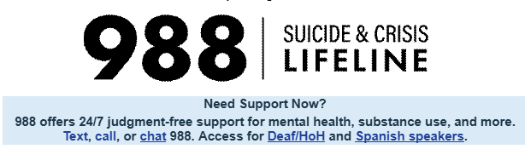

If space, please publish this as well:
Resources and Upcoming Events & Activities

Need Support Now?
988 offers 24/7 judgment-free support for mental health, substance use, and more. Text, call, or chat 988. Access for Deaf/HoH and Spanish speakers.
Area Resources and Organizations
· Elmore County Health Coalition
· Eastern Elmore County Rec District
· Glenns Ferry Historic Opera Theatre
· Mountain Home Arts Council
· Mountain Home Parks & Recreation
· The Watering Hole Community Center
· You Are More
· Youth Rising

