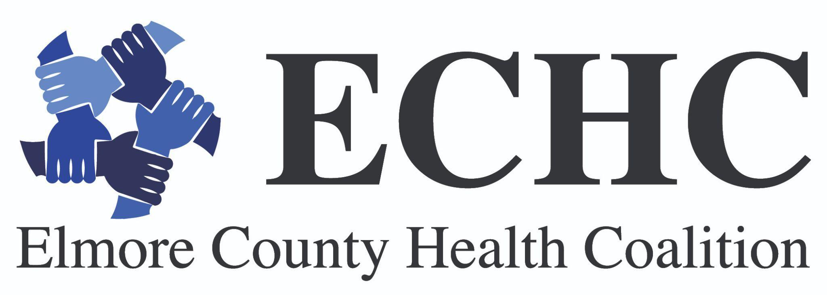
Stronger Together: Connect. Support. Prevent.
This summer, the Greater Treasure Valley 2026 Community Health Needs Assessment (CHNA) was published and distributed throughout the 10-county area, including Elmore County. Based upon a broad range of data gathered and analyzed-- including interviews, focus groups and survey response from community members; health indicators data; and input from community leaders – a list of high priority health needs for the region was identified. Behavioral health was one of the top three priority areas identified, with mental health ranked as the #1 health issue by community survey respondents.
With this urgent priority identified by the community, there’s no better time to share the important mental health resources, and to observe September Suicide Prevention Awareness month activities. Know that suicide prevention touches every part of life – from families and schools to workplaces, faith communities, and health care systems. When people feel connected, valued, and supported, they are more likely to seek help. And when communities come together around a shared commitment to prevention, lives are saved. Check out the information and learn how you can be connected, find value and support, and seek help if you need.
- The people in our lives can be a lifeline. Strong relationships and trusted connections help protect people when life gets hard.
- Suicide prevention starts long before a crisis. Open conversations, shared resources, and visible awareness make a real difference.
- Knowing the warning signs of suicide, in adults and in children and teens, means being able to recognize when someone needs support and connect them to help sooner.
- Communities that talk openly about mental health and suicide help reduce the stigma that keeps people from asking for help.
- Prevention isn't one organization's responsibility. Families, schools, workplaces, faith communities, and health systems each play a part.
- Small acts of connection, such as a check-in, a shared resource, a moment of genuine attention, are how communities take care of each other.
September is one month. The commitment to connection, support, and healing is for all year long.
Learn more about these resources by visiting the Elmore County Health Coalition website or reach out to us at echc@cdh.idaho.gov or 208-327-8547 to learn more.

Upcoming Events and Local Mental Health Initiatives
- You Are More
- BroncoBOLD
- Doyel Ray Hope Center- Breathe
- Over the Brook Gaming- Game Days
- Yellow Buddy Benches (see pg.3)
- Bridging the Gap
- Freedom for Fighters
- YAM Fall Festival (9/25)
- Hope City (9/26)

Resources Available
- St. Luke’s Mental Health Guide
- Supporting Youth Mental Health videos
- Elmore County Domestic Violence Council
- Mountain Home Public Library
- FindHelpIdaho.org

Interested in sharing the message of Suicide Prevention Awareness During the month of September? Check out the SAHMSA Suicide Prevention Awareness Month toolkit to pick out and share the important graphics and messages.

